**EDUCATIONAL PLATFORM APPLICATION**

By:

Nischal Sharma

24th May 2023

Acknowledgement

We would like to express our sincere gratitude to all those who have contributed to the successful completion of our Java project, the educational platform application. This endeavor would not have been possible without the support, guidance, and encouragement from various individuals and resources.

First and foremost, we extend our heartfelt appreciation to our computer science subject professor, Ms. Neetu Singla, for their invaluable expertise and continuous support throughout this project. Their insightful feedback and guidance helped shape our understanding of the subject matter and provided us with the necessary direction to overcome challenges.

We are grateful to our fellow teammates who worked tirelessly as a cohesive unit, bringing their unique skills, dedication, and passion to the table. Each team member played a crucial role in the development, design, and testing phases of the project, and their collaborative efforts ensured its successful completion.

Furthermore, we extend our appreciation to the open-source community and the vast array of resources available online. The knowledge shared by developers and enthusiasts worldwide played a significant role in our learning process and provided us with valuable insights and solutions to complex problems.

We extend our gratitude to all those who have contributed, directly or indirectly, to the successful completion of this project.

Sincerely,

Nischal Sharma

Introduction

In today's fast-paced and interconnected world, the realm of education has undergone a significant transformation. Traditional classroom settings are no longer the sole means of acquiring knowledge, as technological advancements have paved the way for innovative approaches to teaching and learning. One such approach is the emergence of online education platforms, which have revolutionized the educational landscape and opened up new possibilities for students and educators.

**The need for online education platforms in our lives is multi-faced**

* They provide a platform for lifelong learning, enabling individuals to enhance their skills and knowledge beyond the boundaries of traditional education. Online education platforms cater to this need by offering diverse courses and resources that can be tailored to individual learning goals.
* Online education platforms bridge geographical barriers and facilitate learning for individuals who may not have access to quality education due to location constraints or other limitations. These platforms bring together learners and educators from around the globe, creating a vibrant and inclusive learning community.
* Through features like discussion forums, group projects, and peer-to-peer interaction, these platforms create a virtual learning environment that encourages knowledge sharing, critical thinking, and collaborative problem-solving.

In conclusion, the advent of online education platforms has revolutionized the way we learn and teach. The convenience, flexibility, accessibility, and interactive nature of these platforms have transformed education into a dynamic and personalized experience. As we delve into the details of our Java project, an educational platform application, we will explore how our team aimed to harness the power of technology to create a comprehensive and user-friendly platform that addresses the needs of students and educators in the digital age.

Description

Our Java project focused on developing an educational platform application, which aimed to provide a comprehensive and user-friendly online learning experience. This report presents an overview of the project, highlighting the key features and functionalities implemented, as well as the methodology employed throughout the development process.

Throughout the development process, we adhered to best coding practices, incorporating proper exception handling and file management techniques. These practices enhance the reliability and robustness of our application, minimizing the occurrence of errors and improving the overall user experience.

Definition of done:

* All functional requirements are met: The education platform should meet all the functional requirements specified in the project plan. This includes features such as course management, video conferencing, assignments, quizzes, and discussion forums.
* User interface is responsive and user-friendly: The education platform should have a responsive and user-friendly interface that provides a smooth user experience. This includes easy navigation, clear labels, and appropriate feedback messages. Security and privacy measures are implemented: The
* education platform should have appropriate security and privacy measures in place to protect sensitive user data. This includes secure login authentication, encrypted data storage, and access control.
* System performance meets requirements: The education platform should meet the performance requirements specified in the project plan. This includes response times, system load capacity, and scalability.
* Documentation is complete: All necessary documentation for the education platform should be completed, including user manuals, technical documentation, and design specifications.

UML Class Diagram

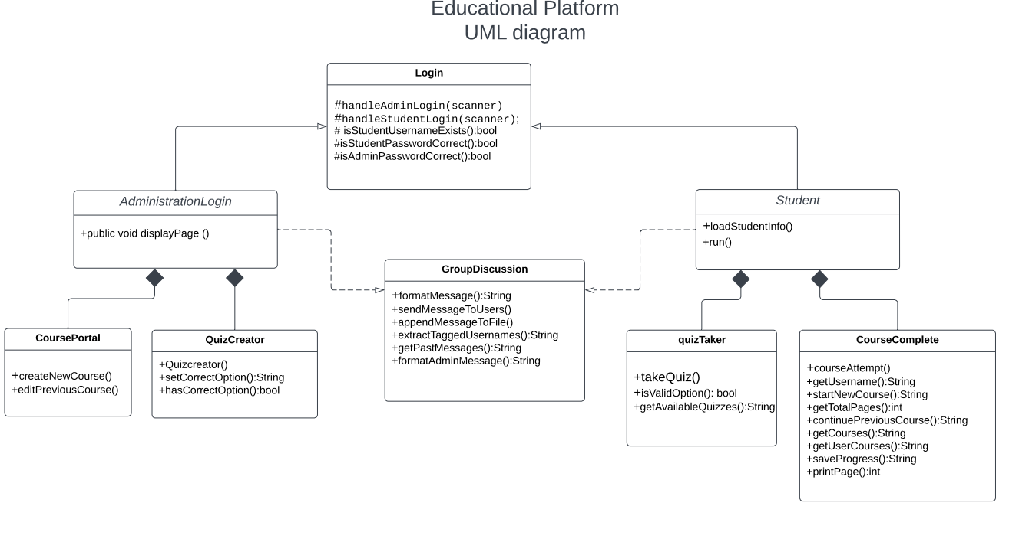

Output Screenshots :

(5.1) Main page:

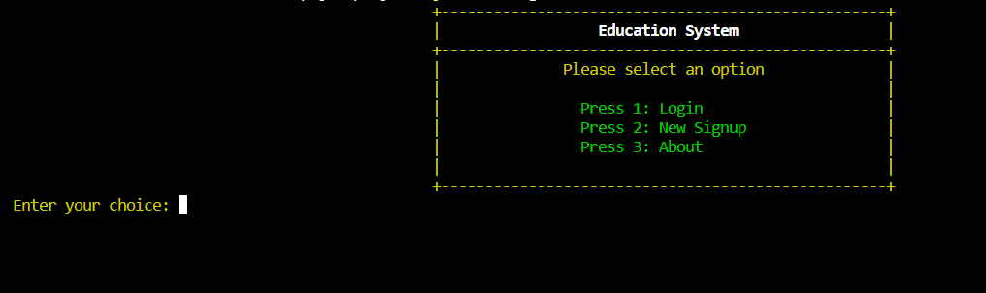

(5.2)Signup page:

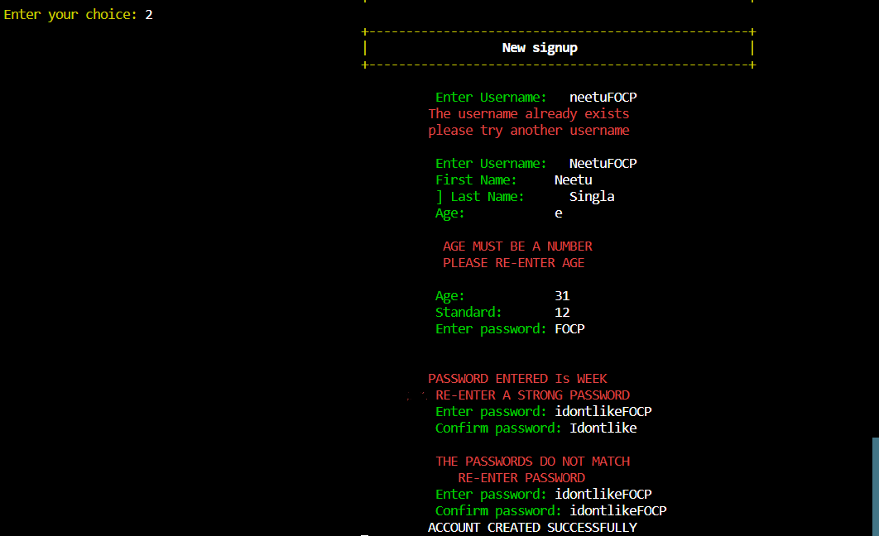

File :

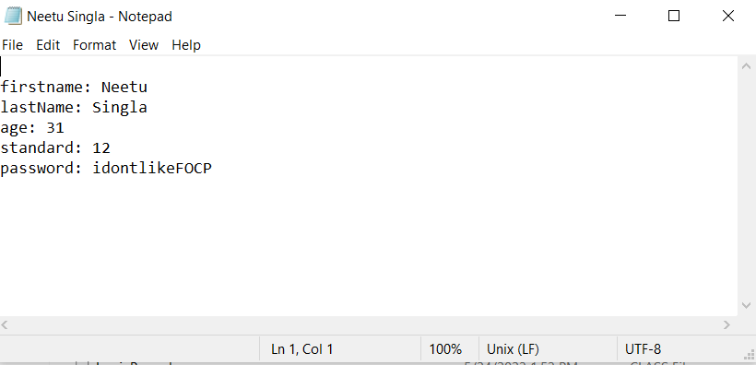

(5.3)Login page:

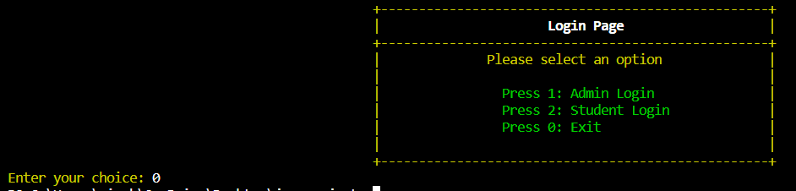

(5.4) Student Login:

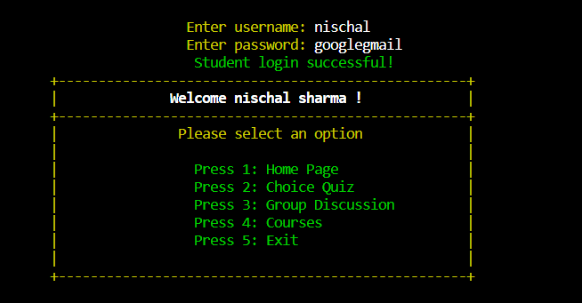

(5.5) Quiz:

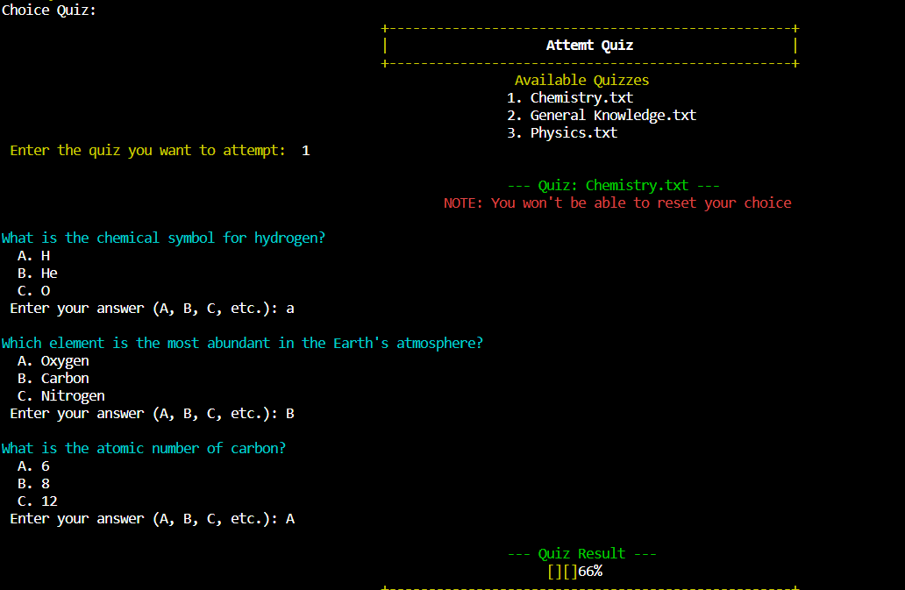

(5.6) Course Study:

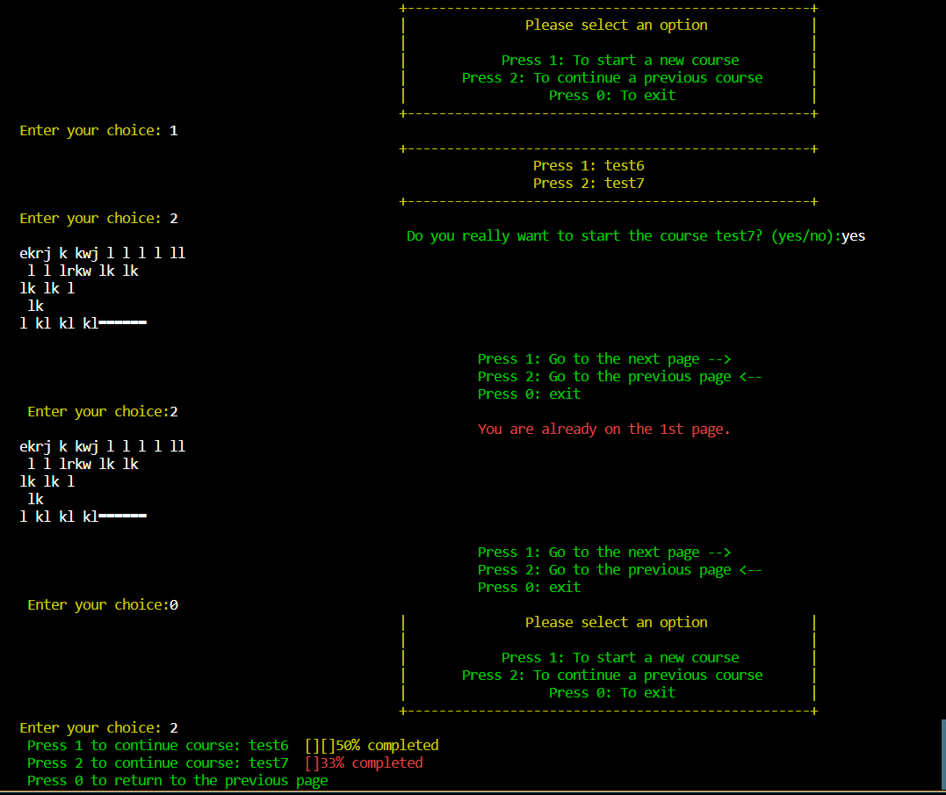

(5.7) Group discussion:

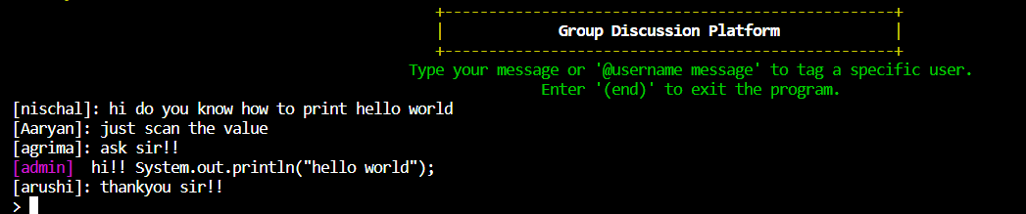

(5.8) Quiz Creater :

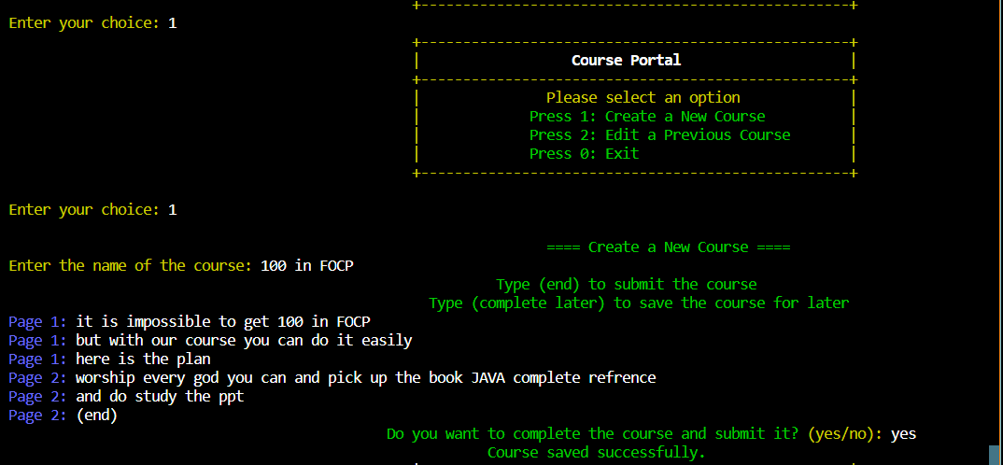

File:

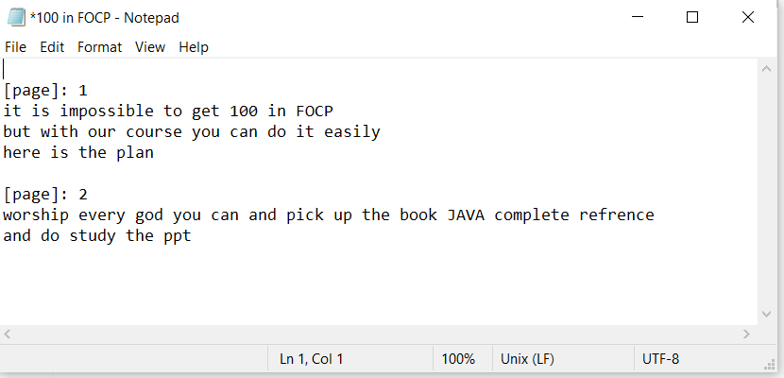

(5.9) Quiz Creator:

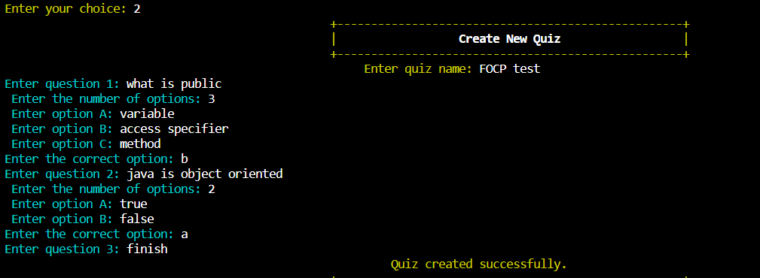

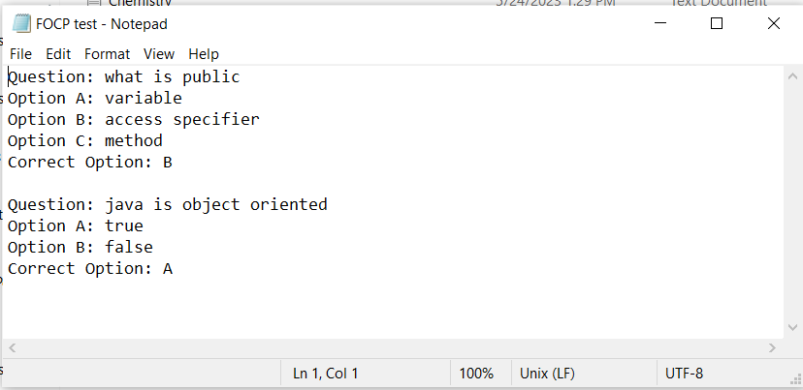

Advantages

Our educational platform offers the following advantages for a rich and effective learning experience:

* Flexibility and Convenience: Users can access educational resources and participate in courses at their own pace and convenience.
* Interactive Learning: Features like quizzes, assignments, and discussion forums promote active engagement and interaction.
* Comprehensive Course Management: Educators can easily create and manage courses, organize materials, and track student progress.
* Collaborative Learning: Group discussions and shared projects foster collaboration, idea exchange, and peer learning.
* Access to a Wide Range of Resources: Students have access to diverse multimedia content, reference materials, and interactive tools.
* Personalized Learning Experience: Students can customize their learning journey by choosing courses, setting goals, and learning at their own pace.
* Continuous Progress Tracking: Tools for tracking and monitoring student progress provide insights and support individualized learning paths.
* Enhanced Communication and Support: Seamless communication between students and educators ensures timely support and guidance.

These advantages create a modern and engaging learning environment that caters to the needs of students and educators.

Limitations

While our Java-based educational platform application has been developed with careful consideration and effort, it is important to acknowledge certain limitations that exist within the project. These limitations include:

* Choice-Based Implementation: The project has been developed using basic Java, resulting in a limited range of choices and functionalities.
* Offline Nature: One of the limitations of our project is that it is not an online platform. This offline nature restricts the ability to access the platform and its resources from different devices or locations.
* Limited Persistence of Group Discussion Messages: In the group discussion feature, messages will only be visible when the code is run again.
* Exception Handling: While we have made efforts to handle known exceptions within the code, it is possible that unforeseen exceptions may still arise. Despite our best efforts, certain exceptions may occur that were not anticipated during the development process. Although we have implemented exception handling mechanisms, in some cases, the application may terminate after displaying an error message.

It is important to note that these limitations do not diminish the overall value and significance of our educational platform application. However, recognizing these limitations allows us to identify areas for potential improvement and future development.

References

● Oracle JAVA (<https://www.oracle.com/in/java/> )

● GeeksForGeeks (<https://practice.geeksforgeeks.org/> )

● w3schools ( <https://www.w3schools.com/java/> )

● Stackoverflow (<https://stackoverflow.com/> )